Reception Remote Learning

WB: 19th April 2022

 | Monday | Tuesday | Wednesday |  | Thursday | Friday
Phonics and H/F Words | - Phonics Read Write Inc Videos on YouTube  - High Frequency words for the week: Revision of all words learnt so far.
Literacy | Buy My Gingerbread  Complete lessons 1 - 5.  https://classroom.thenational.academy/units/persuasion-buy-my-gingerbread-0512
Handwriting | Write your name  Handwriting: 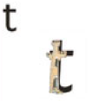  Checklist:  Down the tower and across the tower.  Practise 2 lines of ‘t’ | Practice 1-20  Handwriting:  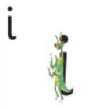  Checklist:  Down the body, dot for the head.  Practise 2 lines of ‘i’ | Write your name  Handwriting  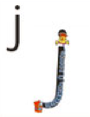  Checklist:  Down his body, curl and dot.  Practise 2 lines of ‘j’ | Practice 1-20  Handwriting:  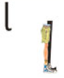  Checklist:  Down the long leg.  Practise 2 lines of ‘l’ |  | Write your name  Handwriting:  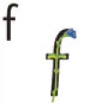  Checklist:  Down the stem and across the leaves.  Practise 2 lines of ‘f’
Maths | Addition and subtraction within 20  Lessons 1 - 5  https://classroom.thenational.academy/units/addition-and-subtraction-within-20-14da
Religious Education | I can talk about why we celebrate Easter.  Talk about what you did during the Easter holidays.  - Why we had a holiday?  - What happened at the first Easter?  - What day did Jesus rise from the dead?  Paint or draw a picture of your favourite thing that you did in the Easter holidays.
Understanding of the world | Growing (plants)  Lesson 1  https://classroom.thenational.academy/units/growing-plants-1978
PSED | Staying Safe  Lesson 1  https://classroom.thenational.academy/units/staying-safe-cd47
Art and Design | Make your very own Supertato!  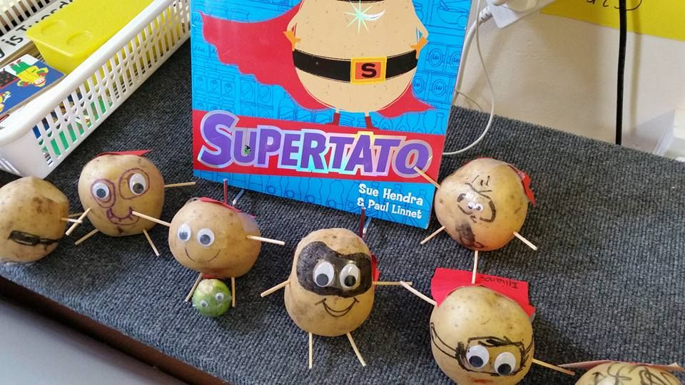  What adventures will Supertato go on today?  You could even make an evil arch nemesis for him to defeat.
Physical Education | Joe Wicks (aka The Body Coach) is live on YouTube every morning at 9am from Monday to Friday. He is offering a daily 30 minute PE lesson until the schools reopen.  Select a video from Cosmic Kids: https://www.youtube.com/user/CosmicKidsYoga

