Reception Remote Learning

WB: 2nd May 2022

 | Monday | Tuesday | Wednesday |  | Thursday | Friday
Phonics and H/F Words | - Phonics Read Write Inc Videos on YouTube  - High Frequency words for the week: Revision of all words learnt so far.
Literacy | The Giant Turnip  https://classroom.thenational.academy/units/the-giant-turnip-79c6  Complete lessons 6 - 10
Handwriting | Practice 1-20  Handwriting:  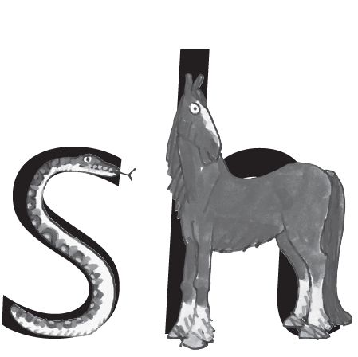  Checklist:  “Shh” says the horse to the hissing snake.  Practise 2 lines of ‘sh’ | Practice 1-20  Handwriting:  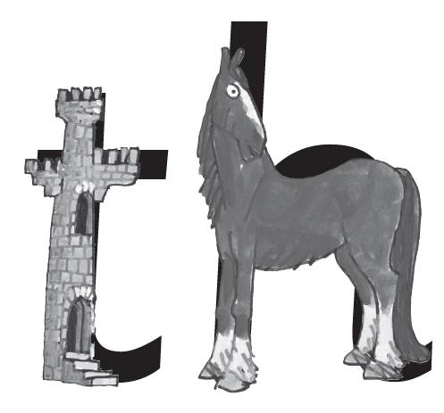  Checklist:  The princess in the tower was rescued by the horse.  Practise 2 lines of ‘th’ | Practice 1-20  Handwriting:  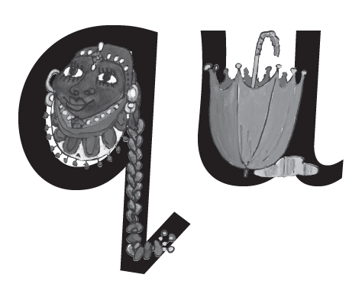  Checklist:  The queen always carries her umbrella.  Practise 2 ‘qu’ | Practice 1-20  Handwriting:  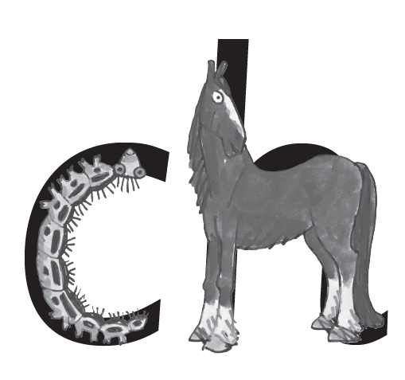  Checklist:  The caterpillar’s hairs went up the horses nose and the horse sais “ch ch choo!”  Practise 2 lines of ‘ch’ |  | Practice 1-20  Handwriting:  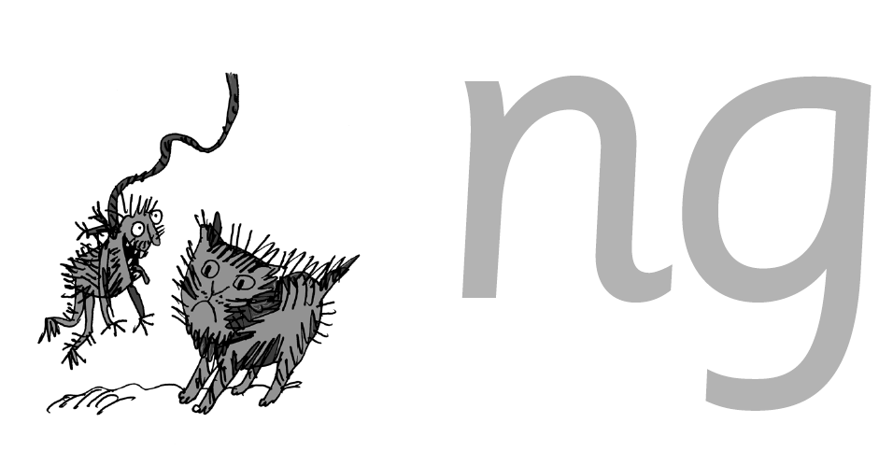  Checklist:  A thing on a string.  Practise 2 lines of ‘ng’
Maths | Measures  Lessons 6 - 10  https://classroom.thenational.academy/units/measures-1948
Religious Education | Watch the video:  https://www.youtube.com/watch?v=K3QkZsKLU2o  Use figures/pictures and retell the story.
Understanding of the world | Feelings  Lesson 1  https://classroom.thenational.academy/units/feelings-e925
PSED | Staying Safe  Lesson 4  https://classroom.thenational.academy/units/staying-safe-cd47
Art and Design | Make a super smoothie!  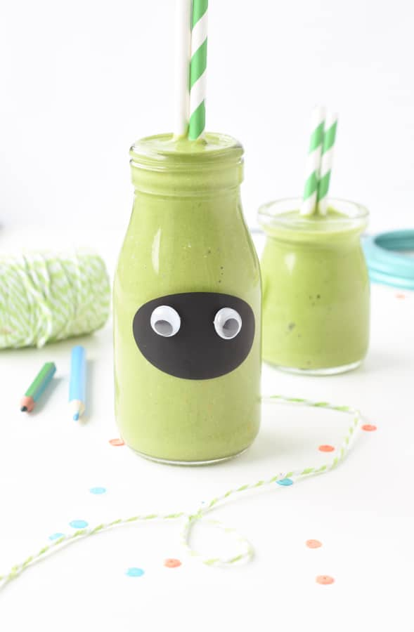 https://www.theconsciousplantkitchen.com/green-smoothie-for-kids/
Physical Education | Joe Wicks (aka The Body Coach) is live on YouTube every morning at 9am from Monday to Friday. He is offering a daily 30 minute PE lesson until the schools reopen.  Select a video from Cosmic Kids: https://www.youtube.com/user/CosmicKidsYoga

